[Title]
Last update [Publish Date] – next update [Publish Date]

Choose an item.

This section contains the indicator at the aggregate level, i.e. EU or if more relevant the global or regional level. The information contained here is the key focus of the indicator; i.e. a summary including key messages, a graph and an assessment text.

Summary (Hard maximum of 500 characters without spaces)

The summary tells the reader about the indicator trend over the examined period and whether or not it helps to achieve the associated policy objective, which can be either quantitative or directional. In the absence of a policy objective, it explains whether the trend is in the right or wrong direction in relation to the issue examined. If there has been an important change over the most recent period of the time series, e.g. over the last year, this is indicated too. Furthermore, if there is a quantitative target, it also indicates whether we are on track to meet it and if not what are the reasons preventing that, e.g. socio-economic drivers, implementation gap etc.

Figure 1. Insert figure title, which should indicate only the phenomenon being measured. Words such as ‘trend’, ‘status’ etc. should be avoided.

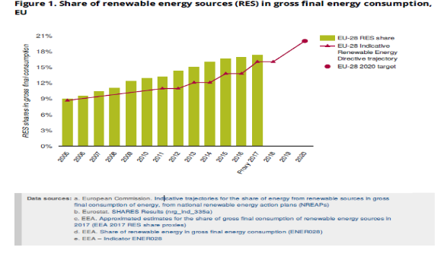

Please embed your figure here. The figure may be a chart, map or table.
- The figure should show the data trend aggregated at the relevant level, i.e. global, EU or sectoral.
- If targets exist, it should also show these and, where possible, how the data are performing with respect to targets.
- If robust projections exist that are important to show, these should appear in the figure. In this case, the indicator definition in the supporting information section should clarify further the assumptions behind the projections.
- Another figure considered very important to the indicator narrative (e.g. some kind of indicator breakdown) can be made accessible via hyperlink.

- Notes: Define any abbreviations here but avoid using them unless essential.
- Explain briefly anything that the reader needs to know to understand the chart. Notes should only be used if absolutely necessary.

Aggregate level assessment (Hard max. 2 000 characters without spaces)

Assessment text remains at the relevant aggregate level (i.e. global, EU, sectoral) and addresses the following:
- Explains in one or two sentences on the environmental rationale of the indicator, i.e. why it matters to the environment that we see an increase/decrease in the value measured.
- Explains in one or two sentences the associated policy objective, which can be either quantitative or directional. More information on the policy objective and related references will be included in the supporting information section. Where there is no policy objective associated with the indicator, i.e. where the indicator addresses an issue that is important for future policy formulation, this text should explain instead why this issue is important.
- IF NECESSARY — Explains any mismatch between what the indicator tracks and what the policy objective/issue is.
- Qualifies the historical trend (e.g. steady increase) and explains the key reasons (e.g. policies) behind it. If there is a quantitative target it explains if we are on track to meet it.
- IF NECESSARY — Explains any recent changes to the trend and why.
- IF NECESSARY — Describes what needs to happen to see adequate progress in future, for instance in order to remain on track to meet targets.
Please cite your work if necessary using the EEA citation style (i.e. EEA, 2020). A full reference list appears in the supporting information section.

Choose an item.

This section shows the indicator at a second level. For example, for an indicator with aggregated data at EU level, the information in this section will be at country level (i.e. for EU, EEA member and EEA cooperating countries) or at regional/urban/local. If more relevant, information at regional or sector level may be provided here.

Figure 2. Insert figure title, which should indicate only the phenomenon being measured. Words such as ‘trend’, ‘status’ etc. should be avoided.

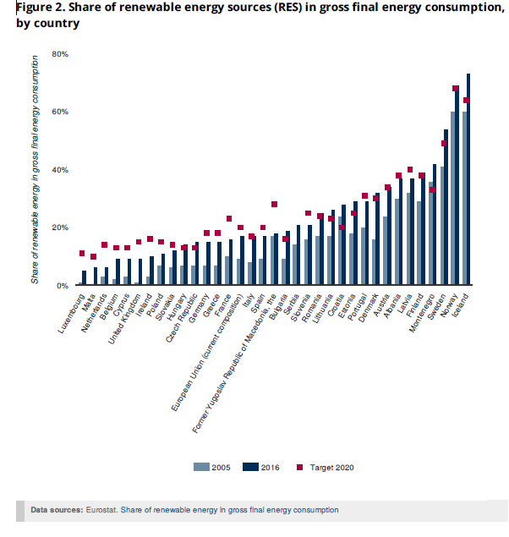
Figure 2 will provide additional information to support Figure 1. Ideally, it will show data by country (e.g. for the first and last years of the EU aggregate time series), including, for example, different country targets. If this is not relevant, regional or sector level information may be shown.
If appropriate, a query option could allow reordering (potential default ordering: best EU performer on top based on latest year’s data; best EEA member country, etc.) for the web version of the indicator.
If appropriate, the full time series of countries could be found via a link to the ‘Data and maps’ section of the website. Here users could reorder or hide some of the countries.

- Notes: Define any abbreviations here but avoid using them unless essential.
- Explain briefly anything that the reader needs to know to understand the chart. Notes should only be used if absolutely necessary.

Disaggregate level assessment (Hard max. 1 000 characters without spaces)

Depending on the indicator context, this text can provide information at country level or, if this is not relevant, at some other level, e.g. sectoral, regional level.
This text interprets the data represented in the chart, rather than describing results, i.e. it provides explanations for some of the results.
The text related to progress at this level does not have to be comprehensive.
If there is no information that adds value to what is already visible there is no need to have any text.

Supporting information

- Information already available in the IMS v.3 (adapted to the transition phase)

Definition - Clear definition of the indicator, including references to standards and classifications
OPEN (max 600 characters with spaces)

Unit of measure - The unit in which the indicator is measured
AUTOMATIC from IMS v.3

Policy/environmental relevance - The degree to which the indicator meets current/potential needs of users
OPEN – max 1000 characters with space

EEA topics - https://www.eea.europa.eu/themes
FIXED – Possible second and third choice

DPSIR - Driving force – Pressure – State – Impact – Response + possible second choice
FIXED – Possible second choice

Typology - Descriptive indicators (type A), Performance indicators (type B), Efficiency indicators (type C), Policy effectiveness indicators (type D), Total welfare indicators (type E)
FIXED – Possible second choice

Methodology - Summary description of the methodology applied to process the indicator (computational method, disaggregation, treatment of missing values, regional aggregates, quality assurance, etc.)
OPEN - max 2 000 characters

Data sources & providers - Link to the data sources (description, collection process, data providers)
AUTOMATIC from data

Geographic coverage - The geographic area covered by the indicator
AUTOMATIC from data

Time coverage - The length of time for which data are available
AUTOMATIC from data

Frequency of dissemination - The time interval at which the indicator is disseminated
FIXED from a list (from ‘every year’ to ‘every 6 years’)

References - Citation of other people’s work in text — including published EEA work — and full bibliographic reference here. Please note that indicators will use Zotero referencing software. For information on referencing, please see Section 3 of the EEA Writing manual.

AUTOMATIC via a Zotero folder for indicators

Related products - Gallery of EEA products related to the indicator & older versions of indicators
How: AUTOMATIC

Contact - info@eea.europa.eu
AUTOMATIC

- Information to be included in the next phase of IMS development (IMS v.4)

UN SDGs - 17 goals from https://w3.unece.org/SDG/Home
FIXED – Possible second choice

Institutional mandate - Legal acts/agreements assigning responsibility to EEA for producing the indicator
FIXED -> ROD - Other (any other legal act/agreement creating the reporting)

Timeliness - Length of time between data availability and the phenomenon described by the indicator
OPEN (from data) – measured in months/years

Accuracy and uncertainties - Includes, among others, comparability (geographical and over time)
OPEN

file:///C:/Users/eeauser/Downloads/Environmental%20indicators%20Typology%20and%20overview%20(2).pdf

