Employment and value added in the environmental goods and services sector
Indicator | Historic trend | 7th EAP selected objective | Environmental acquis selected 2020 objective | Outlook towards 2020
Employment and value added in the environmental goods and services sector | ↑ | Promoting a larger market share of green technologies in the Union and enhancing the competitiveness of the European eco-industry | Fulfil Europe 2020 employment objectives via job growth brought about by the transformation to a low carbon, resource efficient and sustainable economy’ | Yellow
Growth in the sector has stagnated since 2011. The prospects of growth returning are dependent on the sector competing with equivalent sectors in China and the US. This will require continued ambitious policy in the EU.
Overview
The 7th EAP calls for strengthening the market share of green technologies and enhancing the competitiveness of eco-industries by 2020. The Environmental Goods and Services Sector (EGSS) has grown significantly faster than the rest of the EU's economy, both in employment and value added since 2003 and was largely unaffected by the economic crisis. This is partly due to an increase in public sector spending on green infrastructure during the post-crisis years, but has mainly been driven by growth in the renewable energy sector. Growth in the eco-industries has, however, stagnated since 2011, due to increasing global competition and a reduction in domestic investments in renewable energy. The eco-industries will need to retain their global competitiveness to achieve the 2020 7th EAP requirement. This could be assisted through continuing ambitious renewable energy and green growth policy in the EU and Member States but also via more direct assistance.
Setting the Scene
The 7th EAP (EU, 2013) calls for strengthening the market share of green technologies in the Union and enhancing the competitiveness of the European eco-industry. This will not only reduce the environmental impacts of the economy but can also have important socio-economic benefits in terms of increased value added to the EU economy and increased employment. This is also in line with the objectives of the Europe 2020 Strategy objectives to prioritise, inter alia, sustainable growth (EC, 2010) including growing employment in the green economy (EC, 2012)

About the indicator
The environmental goods and services sector (EGSS) is defined as that part of a country’s economy which is engaged in producing goods and services that are used in environmental protection activities and resource management domestically or abroad. EGSS is also called the ‘eco-industries’ or ‘environmental industry’. The income created by the EGSS is evaluated in terms of gross value added, which is the difference between output and intermediate consumption. Employment in the EGSS is evaluated in terms of full time jobs.
The data are broken down by: industry (e.g. services, construction, etc.); environmental protection class (e.g. for wastewater management, waste management, protection of biodiversity and landscapes) and; resource management class (e.g. water management, energy resource management).
The 2000 to 2013 data are Eurostat estimates, with the more recent data based on voluntary surveys sent out to Member States. The year coverage of data from these surveys varies from country to country. Not all country data comprehensively cover all types of activities and all environmental domains. It should also be noted that at present some countries are using different classifications/approaches for calculating employment data. For more information please see http://ec.europa.eu/eurostat/cache/metadata/en/env_egs_esms.htm. From 2017, reporting of data on the EGSS will be mandatory and standardised (Eurostat, 2015).
The EGSS sector does not cover a number of resource management economic activities; for example the management of forest resources, the management of wild flora and fauna and research and development for resource management are excluded.
While both this indicator and the environmental protection expenditure (EPE) indicator are focused on the measurement of environmental activities, they do so from different perspectives. One of the key differences is that EGSS includes (some) resource management activities (which includes renewable energy and energy efficiency), but EPE does not. Another important factor is that EGSS includes output figures for exports, and EPE includes the purchase of imported goods, therefore comparison of aggregate measures of expenditure and production from each set of statistics should take this difference into account. Another factor which complicates comparison is that EGSS output figures are at basic prices (excluding taxes), while EPE figures are at purchase prices and therefore include taxes. (UN, 2014).

Policy targets and progress
There are no quantitative 2020 targets on the level of employment or output from the eco-industry sector, i.e. the Environmental Goods and Services Sector. However, Europe is seen as a global leader in the development of environmental goods and services and as such there is significant potential foreseen in exporting this expertise (EC, 2015).
The latest data shows that from 2000 to 2013, employment in the EGSS (based on estimated data for the EU as a whole) increased by some 49%. In 2013, about 4.2 million people were employed in this sector (Eurostat, 2015). The increased awareness of the need to combat environmental pollution and preserve natural resources, as well as the obligations to comply with the environmental acquis, has led to an increase in the supply and demand of environmental goods and services, i.e. products to prevent, measure, control, limit, minimise or correct environmental damage and resource depletion.

Figure 1 Trends in employment and value added in the Environmental Goods and Services Sector (EGSS) compared to the average across the economy, EU
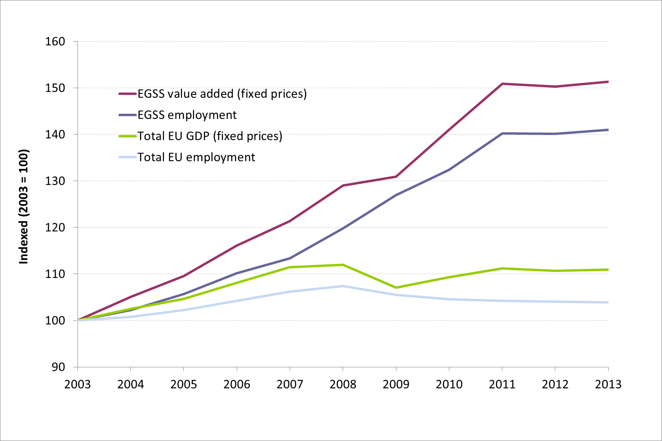
Data sources: Eurostat env_ac_egss1, env_ac_egss2, lfsi_emp_a, nama_10_gdp
As can be seen, the EGSS has seen strong growth in employment and value added since 2003, far higher than average growth rates across all economic sectors in the EU. This above average growth has led to an increase in the sector's contribution to GDP, growing from 1.5 % in 2003 to 2.0 % in 2013, and its contribution to total employment in the EU growing from 1.4 % to 2.0 % over the same period.
A point of key interest is that the eco-industries continued to grow even in the years immediately following the financial crisis. According to Görlach et al (2014) this was partially a result of the innovative nature of the industry and Europe's competitiveness on the global market, but also due to an increase in public spending on environmental protection and renewable energy during the post-crisis years (see also under the Environmental Protection Expenditure Briefing). Some of the most successful government interventions have been investment support schemes, which provided investors with a high degree of investment certainty. Especially in difficult economic times, governments can induce significant private investment in the eco-industries by providing the certainty that investors cannot get elsewhere (Görlach et al, 2014).
The EGSS can be divided between environmental protection activities - which include preventing, reducing and eliminating pollution and any other degradation of the environment - and resource management activities - which include management of energy resources (renewable energy production and equipment and installations for heat and energy savings). Growth in both areas has been strong but has been particularly high in the resource management area; the value added of this sector grew from 50.7 billion Euro in 2003 to 116.7 billion Euro in 2013 (at 2010 prices). The renewable energy sector has been the key driver in this growth. Environmental protection activities still represent the major element of the EGSS, however, with a value added of 156 billion Euro in 2013.
EU employment in environmental protection activities and for water and energy resources management is estimated at 4.15 million full-time equivalents by 2013 (see figure 2). The main driving force for the estimated increase since 2000 is the growing importance of activities that manage energy resources, in particular the production of energy from renewable sources, the production of wind and solar power stations and equipment and installations for heat and energy savings (Eurostat, 2016).

Figure 2 Employment in the Environmental Goods and Services Sector, EU-28
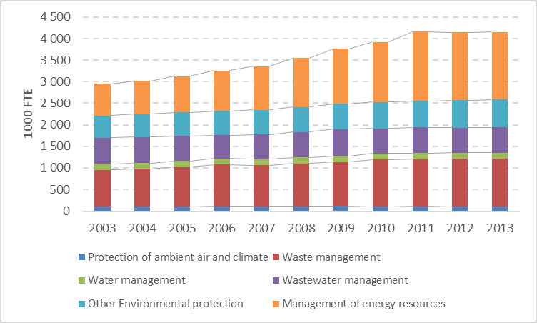
source: Eurostat (dataset: env_ac_egss1)
The overall increase in employment and value added of the EGSS sector is a positive development. However, it should be noted that a greener economy is not inclusive and socially sustainable by default, and the transition phase is likely to entail some challenges, particularly within certain sectors and for certain workers. Consequently, a comprehensive approach is needed that ensures that green jobs are also decent jobs that contribute to social inclusion (ILO, 2008).
Despite the successes of the sector, recent trends are not so positive, with employment and value added growth in the sector having stagnated since 2011. This may be a result of increasing competition from other parts of the globe including the US and China (Görlach et al, 2014). A further driver has been a slump in domestic investments in renewable energy. In 2015, EU investment in renewables reduced by 21% compared with the previous year as a result of ongoing uncertainty on the future of support mechanisms and lower investment capacity in some EU countries (UNEP, 2016) (see the Share of Renewable Energy briefing). The 2020 outlook of the sector in terms of an increased contribution to the EU’s employment and economy is therefore uncertain.

Outlook beyond 2020
The EGSS is needed in order to achieve growth which is both low carbon and decoupled from resource use, as per the long term vision of the 7th EAP. There are clear signs of a strengthening policy focus extending beyond 2020 on energy efficiency, such as the extension of the targets for renewable energy and the new targets for waste recycling under the Circular Economy Package. These signs suggest that there could be growth in EGSS employment and output beyond 2020.
Changes in the policy framework, such as reductions in the subsidies provided to support electricity from renewable source at Member State level can jeopardise this situation in those Member States, as these changes risk reducing demand for the EGSS. There is also increasing global competition in parts of the EGSS, with the prime example of this being in the manufacture of photovoltaic panels. If the EGSS is to continue growing the associated eco-industries in the EU will need to retain their global competitiveness. This could be assisted through ambitious EU and Member States renewable energy and green growth policy but also via more direct assistance such as investment support schemes which provide investors with a high degree of investment certainty.
Footnotes and references
EC, 2010. COM(2010)2020: Communication from the Commission. Europe 2020, A strategy for smart, sustainable and inclusive growth
EC, 2012. COM(2012)173: COMMUNICATION FROM THE COMMISSION TO THE EUROPEAN PARLIAMENT, THE COUNCIL, THE EUROPEAN ECONOMIC AND SOCIAL COMMITTEE AND THE COMMITTEE OF THE REGIONS Towards a job-rich recovery
EC, 2015. The Environmental Goods Agreement (EGA): Liberalising trade in environmental goods and services. European Commission Press Release, 8th September 2015. Brussels. http://trade.ec.europa.eu/doclib/press/index.cfm?id=1116
EU, 2013. Decision No 1386/2013/EU of the European Parliament and of the Council of 20 November 2013 on a General Union Environment Action Programme to 2020 Living well, within the limits of our planet. Annex A. Paragraph 43
Eurostat, 2015. Environmental economy - employment and growth http://ec.europa.eu/eurostat/statistics-explained/index.php/Environmental_economy_-_employment_and_growth
Eurostat, 2015. A Practical Guide for the Compilation of Environmental Goods and Services (EGSS) Accounts. January 2015. Eurostat – Unit E2 http://ec.europa.eu/eurostat/documents/1798247/6191549/Practical-guide-towards-compiling-EGSS-statistics-March2015.pdf/f0f8c6c1-0ae9-4f53-9c94-afcc190cc5ba
Eurostat, 2016. Statistics Explained, Environmental goods and services sector. http://ec.europa.eu/eurostat/statistics-explained/index.php/Environmental_goods_and_services_sector
Görlach et al, 2014. How crisis-resistant and competitive are Europe’s Eco-Industries. Ecologic Institute, Berlin. http://docplayer.net/9826167-How-crisis-resistant-and-competitive-are-europe-s-eco-industries.html
ILO, 2008. Green Jobs: Towards Decent Work in a Sustainable, Low-Carbon World, UNEP/ILO/IOE/ITUC, September 2008. http://www.unep.org/PDF/UNEPGreenjobs_report08.pdf
UN, 2014. System of Environmental-Economic Accounting, 2012 – Central Framework. United Nations. http://unstats.un.org/unsd/envaccounting/seeaRev/SEEA_CF_Final_en.pdf
UNEP, 2016. Global trends in renewable energy investment 2015, Frankfurt School of Finance and Management, UNEP Collaborating Centre and Bloomberg New Energy Finance, Frankfurt, http://fs-unep-centre.org/publications/global-trends-renewable-energy-investment-2016

