Briefing title

[Introductory text template – maximum 250 characters without spaces
Displayed on website as a single paragraph
Links may be included in the introductory text]

This briefing is about/provides information about (insert description of topic here). It is based on data provided/compiled by (insert data sources here) and is published in the context of/supports (insert relevant EU policy here).

[Example inspired by the European bathing water quality in 2023 briefing:

This briefing is about the quality of Europe’s bathing waters in 2023 and is complemented by a map viewer to help readers take informed decisions on where to bathe. It is based on data reported by EU Member States for the 2020-2023 bathing seasons and supports the Zero pollution action plan.]

Key messages
[Maximum five bullet points, approximately 750 characters in total without spaces]

Title for main body text
[Main body text – maximum 8,000 characters without spaces]

Body text
Map/Figure/Table X. Caption [Insert your caption here (delete feature and insert your feature)]
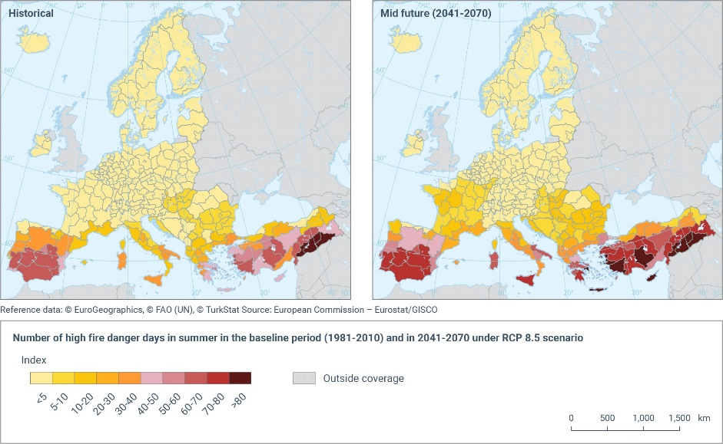
Note(s): [Insert note(s) here]

Source(s): [Insert source(s) here]
Please use standard citation style, i.e. EEA, 2024, and state whether the figure is adapted from an existing figure as follows: Adapted from JRC, 2024.

Note(s):
[Insert notes covering the full briefing here]

Acknowledgements
[Generic text – to be adjusted according to acknowledgement policy]:
The European Environment Agency (EEA) would like to thank [its partners from the European Environment Information and Observation Network (EEA member countries and European Topic Centres)], [its Scientific Committee], [other EU agencies /name], [EU institutions /name e.g. European Commission Directorate General for Environment/Climate Action] and [international organisations/name of an organisation] for their valuable contributions and input. [Amend/delete as appropriate]

References:
[Insert references here. If done manually, please check guidelines for style]

Metadata
Geographical coverage: [For example: EEA-33, EU-28 + Switzerland, etc.]
Time coverage: [Period that the briefing covers. For example, 2000-2019]
Keywords: [Please suggest at least three keywords relevant to this briefing (preferably not topic names or words that are already present in the title)]
Project code: [Management Plan System (MPS) 3-digit code - for example: 1.2.3]

