Towards draft guidelines for EEA’s dashboards harmonization

Roger Milego (UAB)

ETC partners: S4E, UMA, GISAT, UAB
EEA task manager: Sebastien Petit
EEA deliverable lead: Eva Ivits
Support from COM: Gaia Russo, Laura Cernahoschi

Version 2.0
Date: 10.11.2023

Environment Agency Austria; UBA
Spittelauer Lände 5
1090 Wien Austria
Telephone: +43 1 31304 3371
Mobil: +43 664 966 8629
Contact andreas.LITTKOPF@umweltbundesamt.at

.

Table of contents

Background and objectives 4
1. Dashboard types by target audience 5
1.1. Challenge 5
1.2. Best practices 6
2. Storytelling. How to better communicate with dashboards? 7
2.1. Challenge 7
2.2. Best practices 7
3. Dashboard sizes and multidevice approach 8
3.1. Challenge 8
3.2. Best practices 12
4. Layout. Placing dashboard elements 13
4.1. Challenge 13
4.2. Best practices 14
5. Dashboard styling 16
5.1. Challenge 16
5.2. Best practices 16
5.2.1. Fonts 16
5.2.2. Colours 16
5.2.3. Maps 18
5.2.4. Tooltips 20
5.2.5. EEA visual identity 21
6. Navigation and dashboard actions 22
6.1. Challenge 22
6.2. Best practices 22
7. Summary of proposed guidelines 26
Annex 1. Example filled-in template for dashboard development 28

Table of Figures

Figure 1. EEA’s Audience segmentation 5
Figure 2. EEA Data products based on audience segmentation 6
Figure 3. Size options when creating dashboards in Tableau 8
Figure 4. Options available within the fixed size selection in Tableau 8
Figure 5. Automatic size option for dashboards in Tableau 9
Figure 6. Size customisation within ranged size option in Tableau 9
Figure 7. Selection of device-specific layouts for dashboards in Tableau 10
Figure 8. Automatic layout for phone devices in Tableau 11
Figure 9. Customisation of device-specific layout for Tableau dashoards 12
Figure 10. Tiled vs floating layout in Tableau dashboards 13
Figure 11. Example of how to organise dashboards. In this case, two different pages, with the content placed from top to down 15
Figure 12. EEA colour palettes in Tableau 17
Figure 13. New EEA colour palette. Source: https://eea.github.io/volto-eea-design- system/docs/webdev/Guidelines/colours/ 17
Figure 14. Map example, related to drought impact area. 19
Figure 15. Map example, related to net land take vs. artificial surfaces. 19
Figure 16. Map example, related to CLC statistics 20
Figure 17. Map example, related to land use pressure indices. 20
Figure 18. Example of tooltip information 21
Figure 19. Example of tooltip information which contains a complementary chart 21
Figure 20. Tableau story organised by tabs 22
Figure 21. Usage of navigation buttons in a dashboard page layouted vertically 23
Figure 22. Use of navigation buttons to organise more complex information 24
Figure 23. Example of navigation button to go to an information page 24
Figure 24. Instructions page in preparatory template 29
Figure 25. Basic mandatory information page in preparatory template 30
Figure 26. Dashboard communication page in preparatory template 31
Figure 27. Dashboard design page in preparatory template 32

Background and objectives
This document stands as the conclusive draft of an EEA guidance document aimed at enhancing the design and development of dashboards to facilitate harmonized and effective communication. It represents the culmination of extensive efforts that commenced in 2022 under ETC-DI task 3.3.1, titled "Adaptation of Dashboards and Draft Guidebook for Improved and Coherent Communication with Dashboards." These endeavors encompassed the inaugural workshop on EEA's dashboard harmonization, held on November 11th, 2022, as an integral component of the aforementioned activity. Furthermore, this work extended into 2023 within the framework of ETC-DI task 3.3.1, now titled "Dashboards Harmonization for Enhanced and Effective Communication".
In the later stages of spatial data integration to support EEA assessments, the creation of interactive dashboards is a common practice. The process of generating data cubes through JEDI ultimately results in a Tableau data source file, enabling the utilization of Tableau to produce interactive views that blend tables, charts, maps, text, images, and filters in diverse ways. Tableau dashboards can be shared on Tableau Server and integrated into web pages. Furthermore, ESRI's ArcGIS software is also employed for the development of map-oriented dashboards.
Up to this point, our primary focus and resources have been channeled into ensuring the reliability of data results and crafting comprehensive dashboards to support expert assessments. However, there is now a pressing need to shift our emphasis toward the communicative and design elements of the dashboards we share with the wider audience. These dashboards should be customized for their target audiences, convey compelling narratives, and be visually engaging and user-friendly.
While the EEA's COM team oversees the management of reports, indicator publications, and web content, each governed by distinct rules and standards, we currently lack a similar approach when it comes to interactive dashboards. This document serves as the initial stride toward establishing a shared set of best practices for the creation of dashboards intended for publication within the EEA. Although our immediate focus is primarily on Tableau dashboards, our vision is to expand these principles to encompass ArcGIS dashboards as well.
The upcoming pages delve into various facets and components related to dashboards. They explore the challenges these elements pose and offer practical recommendations for achieving a cohesive and consistent appearance across EEA dashboards. The topics discussed are:
- Dashboard types by target audience
- Storytelling. How to better communicate with dashboards?
- Dashboard sizes and multidevice approach
- Layout. Placing dashboard elements
- Dashboard styling
- Navigation and dashboard actions

Dashboard types by target audience

Challenge

To kick off the process of establishing guidelines and best practices for dashboard production, our first step involves a discussion about the various types of dashboards in use and which ones are specifically addressed in this guidance document. The EEA, its topic centers, and its consultants create different types of dashboards, and it's beneficial to attempt categorizing or classifying them. Several key aspects can aid in determining the nature of the dashboard in question, which can be summarized as follows:
- Target Audience
- Purpose
- Content
In 2021, the EEA identified two primary categories of target audiences: non-technical and technical. Within the non-technical audience, two subtypes have been delineated based on time availability:

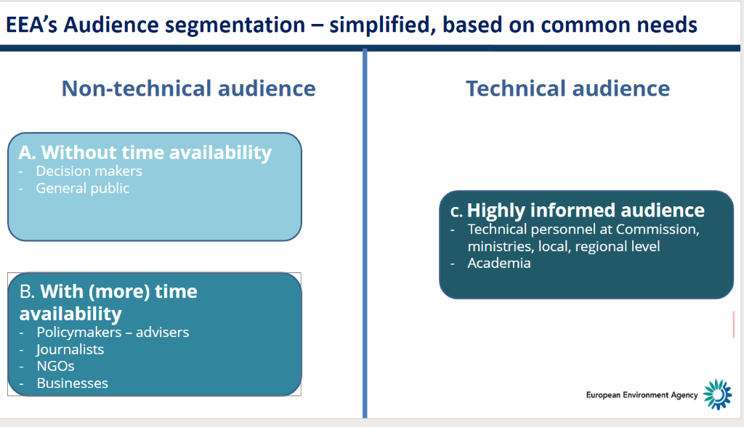
Figure 1. EEA’s Audience segmentation

Based on that audience segmentation in three types (A, B and C), different data products were proposed as more suitable for each audience type:
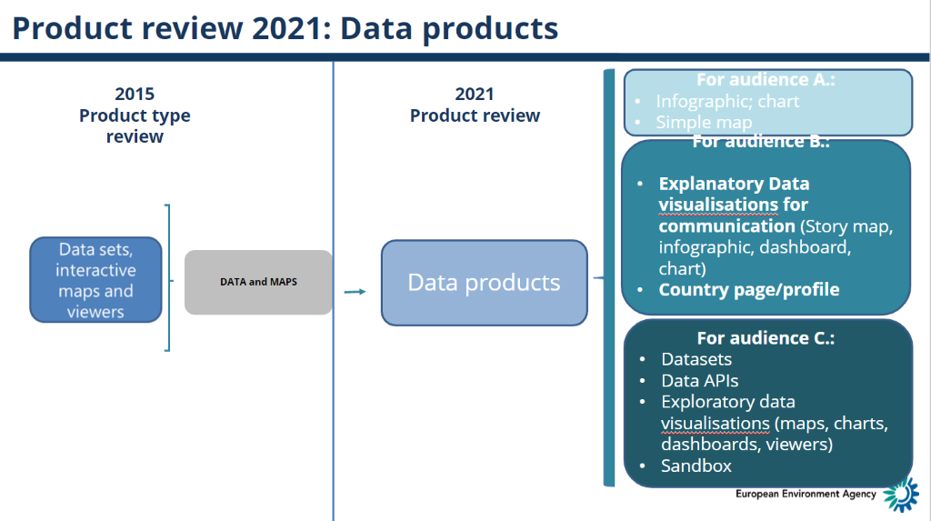
Figure 2. EEA Data products based on audience segmentation

When it comes to dashboards, we can observe that they are primarily designed for audience types B and C. Dashboards typically introduce a level of interactivity and complexity to the data, making them suitable for either a technical audience or a non-technical audience with sufficient time to engage with the data and comprehend the outcomes.
Historically, within ETC-DI and its predecessor, ETC-ULS, dashboards were predominantly created within the context of assessments, primarily for purposes such as data exploration, trend identification, and indicator development. Consequently, these dashboards were tailored for a technical audience, with less emphasis on harmonization, design, or user-friendliness. In some instances, though, dashboards were produced for public consumption without clear, shared rules, guidelines, or best practices to guide their development.
In summary, there exist diverse dashboards serving different purposes and targeted at different audiences. The question then arises: which among them should be harmonized, and to which of these dashboards should the emerging guidelines be applied?

Best practices

In response to the previous question, consensus has been reached among experts who participated in the workshop on dashboard harmonization: all dashboards slated for publication on the EEA's website or any of EEA's thematic platforms must undergo harmonization. By harmonization, we mean that these dashboards should exhibit a consistent look and feel, and they should incorporate the recommendations and best practices outlined in this guidance document, along with its future updates. These guidelines will form a part of a publication policy to be disseminated and, to some extent, enforced by COM across the EEA, ETCs, and consultant stakeholders to achieve the overarching goal of harmonizing dashboards.
As a general guideline, dashboards designed for audience type B should be published on EEA's website, whereas those intended for audience type C should find their place on thematic platforms whenever available. While the look and feel may be uniform, the content can vary, leading to some best practices being relevant to only one type of dashboard. This distinction will be explicitly mentioned in the relevant sections as needed. In a broader context, these guidelines predominantly apply to dashboards of B and C types unless explicitly specified.
It is widely acknowledged that the content, dashboard elements, and more will be contingent upon the specific type of dashboard, be it B or C. This aspect will be explored further in the subsequent chapter on storytelling.

Storytelling. How to better communicate with dashboards?

Challenge

There are several points to be taken into account when designing dashboards for an effective communication. Tableau has some recommendations in this regard:

- Start with questions: What are you trying to say? What's your goal?
- Know your purpose and audience
- Leverage the most-viewed spot
- Design for the real world
- Limit the number of views
- Add interactivity to encourage exploration

All these elements are important and they are addressed within these guidelines.

Tableau has published some very well-designed dahsboards, which can provide some ideas for a better communication through very nice designs:

- https://public.tableau.com/app/discover/viz-of-the-day

- https://public.tableau.com/app/profile/jon.bearscove/viz/ArtCompetitionsintheOlympics/ArtintheOlympics

- https://www.tableau.com/blog/explore-iron-viz-entries-visualizing-arts

Best practices

Creating a successful dashboard hinges on careful planning before initiating the design and development process. It is of utmost importance to proactively consider and define its objectives, target audience, key messages, contextual relevance, and other critical factors. To facilitate this preparatory phase, we've introduced a dedicated template (see Annex 1. Example filled-in template for dashboard development) designed to guide users in establishing these key points in advance. This, in turn, should greatly inform and streamline the subsequent phases of dashboard design and implementation.
It is strongly recommended filling in the template in all cases, but it is especially required for dashboards of type B.

Dashboard sizes and multidevice approach

Challenge

When designing a dashboard or a story in Tableau, there are three options regarding its size:
- Fixed size
- Automatic
- Range

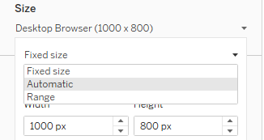
Figure 3. Size options when creating dashboards in Tableau

FIXED SIZE: In this case, the size of the dashboard is defined by a predefined width and height. There are several options of fixed size dashboards. In brackets, width (horizontal) and height (vertical) pixel sizes:

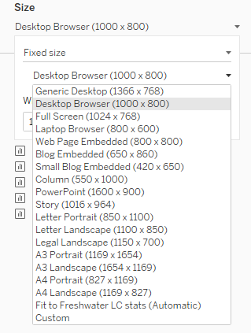
Figure 4. Options available within the fixed size selection in Tableau
AUTOMATIC SIZE
With this option the dashboard and its content adapt to the screen they are displayed on, as there is no fixed width or height. Although it is a good approach in most cases, depending on the type of content your dashboard includes, the final visualisation might not be optimal.

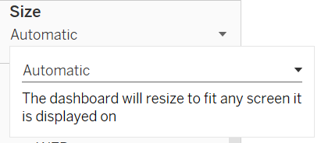
Figure 5. Automatic size option for dashboards in Tableau

RANGED SIZE: This option is a mix between fixed and automatic. Users can define the MIN and/or MAX ranges for dashboard visualization. Within the range defined by the user, dashboards will adapt automatically based on the screen size.

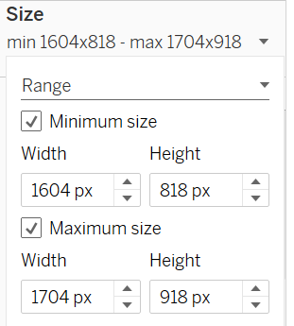
Figure 6. Size customisation within ranged size option in Tableau

In general practice, we've predominantly utilized the Automatic set-up for its optimization on larger screens, making the most of their expansive real estate. However, it's worth noting that when integrating the content into certain webpages, the visual experience may not be as ideal. This limitation is especially evident when viewing the dashboards on various mobile devices, including tablets and smartphones.
Additionally, Tableau offers the flexibility to establish distinct layouts tailored to different devices. Typically, we rely on the Default layout, which serves as the default choice and is automatically applied across all devices when no specific device-based layouts are designated.
However, Tableau allows for the creation of three types of device-based layouts:
- Desktop
- Tablet
- Phone

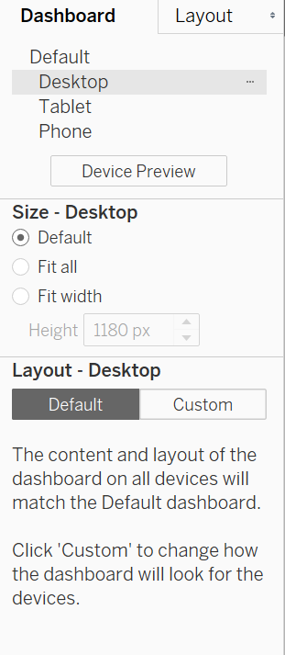
Figure 7. Selection of device-specific layouts for dashboards in Tableau

For instance, when selecting “Phone” as a device, Tableau sets up an automatic layouting for that type of device:
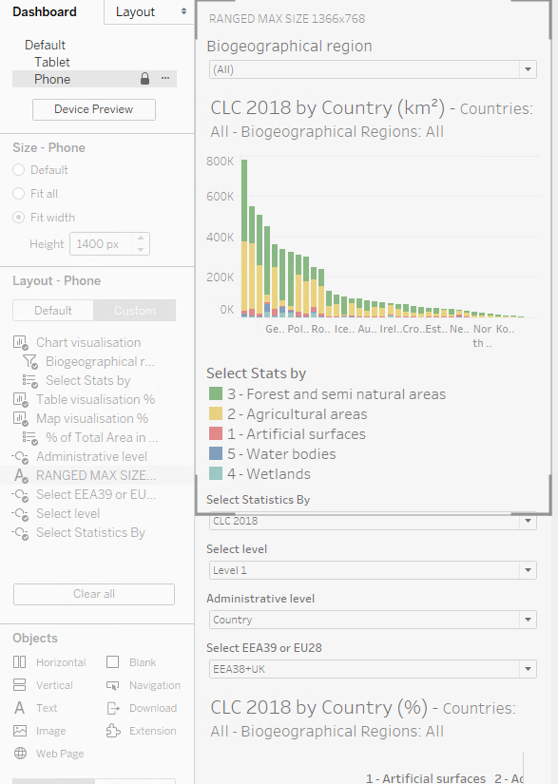
Figure 8. Automatic layout for phone devices in Tableau

However, users can edit the layout and customize it by device type, e.g., by removing some elements from the original dashboard:

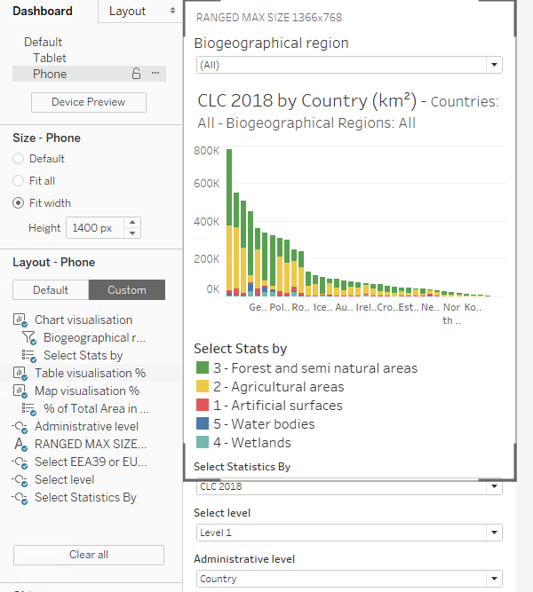
Figure 9. Customisation of device-specific layout for Tableau dashoards

Best practices

The size of a dashboard largely depends on two key factors: its content, which dictates the number of elements it contains, and its intended placement, whether it will be embedded in a website or not.
Generally, for type B dashboards, it's advisable to aim for a fixed width ranging between 900 and 1100 pixels to ensure compatibility with various embedment scenarios. However, it's essential to conduct testing during the initial stages to assess how well the dashboard aligns with the specific web page it will be featured on. In terms of height, there are no strict rules; it varies according to the content. A scrollable dashboard is a natural and adaptable choice for various devices, making it the preferred design option.
In the case of type C dashboards, there's greater flexibility, and automatic layouts can be applied, particularly when they enhance exploration and analytics – the primary objectives for this type.
When it comes to adaptive solutions, type B dashboards should allocate time and resources for adapting to mobile devices. On the other hand, type C dashboards do not require such adaptation, as their main purpose is exploratory and is typically accessed via computers. Mobile layouts for type B should be streamlined and straightforward, with fewer elements, while providing the option to refer to the desktop version for more in-depth details when desired.

Layout. Placing dashboard elements

Challenge

Dashboards are versatile tools that can incorporate tables, charts, maps, text, images, and more. It's crucial to establish best practices for crafting layouts that seamlessly integrate these diverse elements, particularly when creating communicative dashboards intended for public consumption. Additionally, it's essential to consider the preferences and needs of the target users.
During our initial workshop on dashboard harmonization, we delved into various methods for effectively structuring information. Traditionally, we've leaned on Tableau stories to accommodate exploratory data needs. However, they aren't always the best choice for clear communication. Another option worth considering is a vertical layout, akin to web page designs. In cases where there's an abundance of information, we can create separate pages with navigation buttons to strike a balance between exploration and user-friendliness.
Furthermore, these dashboard elements can be arranged in various ways, such as organized in a grid-like structure (tiled) or placed as floating components layered on top, as exemplified in Figure 10.
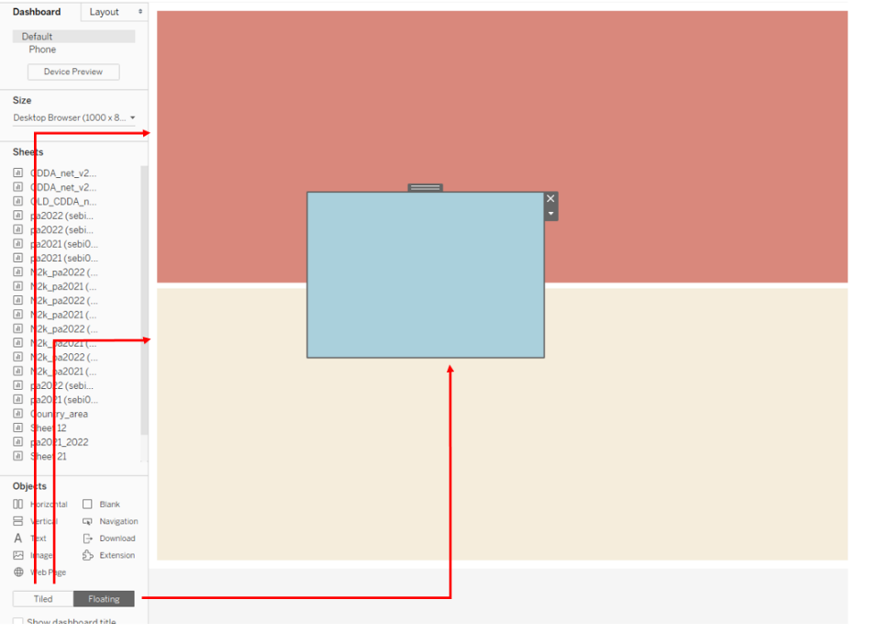
Figure 10. Tiled vs floating layout in Tableau dashboards
In conclusion, adopting a top-down, vertical organization for elements in a dashboard aligns with user expectations, promotes ease of use, enhances content prioritization, and ultimately contributes to a more effective and user-friendly dashboard design. This approach simplifies the user's interaction with the dashboard and helps them make more informed decisions.

Best practices

The main recommendation regarding placing dashboard elements is organizing the different elements in a dashboard vertically, following a classical top-down navigation structure akin to web pages, as shown in Figure 11. This option offers several compelling advantages that enhance user experience and streamline information presentation:
- Intuitive Flow: Vertical organization mimics the natural reading and scanning patterns of most users, making it instinctively easy to follow. Users tend to start at the top and work their way down, just as they do when reading a document or a webpage. This approach minimizes cognitive load and ensures that users find what they need more efficiently.
- Prioritization: Placing elements in a top-down structure allows for clear prioritization of content. The most important or frequently accessed information can be positioned at the top, ensuring that it catches the user's attention first. As the user scrolls down, they encounter less critical information, preventing overwhelm.
- Consistency with Web Usability: Users are accustomed to navigating web pages from top to bottom. Adhering to this familiar structure promotes consistency and reduces the learning curve for users. Dashboards that mirror web page navigation create a seamless transition and make users feel more at ease.
- Mobile Responsiveness: Vertical organization is inherently mobile-friendly. Many users access dashboards on mobile devices, where vertical scrolling is the norm. A top-down approach ensures that the dashboard's design remains responsive and user-friendly across different screen sizes.
- Content Hierarchy: Dashboards often contain a mix of data, text, and visual elements. A vertical layout enables the clear definition of content hierarchy. Key performance indicators, summaries, or critical information can be placed at the top, with supporting details below. This hierarchy simplifies information digestion.
- Enhanced Contextual Understanding: A top-down structure encourages a logical flow of information. Users can better understand the context as they progress through the dashboard, which is essential for making informed decisions based on the presented data.
- Reduced Cognitive Dissonance: Scrolling vertically is less disruptive than navigating horizontally or in multiple directions. A top-down structure minimizes cognitive dissonance by providing a consistent and smooth navigation experience.
- Accessibility and Readability: A vertical layout aligns with accessibility guidelines. It ensures that screen readers and other assistive technologies can interpret the content correctly, making the dashboard more inclusive.

Furthermore, it is advisable to exercise caution regarding the number of elements included in a dashboard, particularly in the case of B-type dashboards. A prudent approach would involve featuring a single chart and map, or a combination of one chart along with one table, complemented by a modest amount of explanatory text, a title, and a few user-friendly filters. This streamlined composition can contribute to a more effective and user-friendly dashboard.
In terms of the layout of elements on each page, a tiled configuration is our preferred approach, with floating elements being reserved for situations where they offer clear advantages. For instance, the placement of legends around charts or maps may necessitate the use of floating elements.
Additionally, it is advisable to make use of the provided template for pre-designing the various pages and their content prior to commencing the dashboard construction process. This practice can enhance efficiency and streamline the overall workflow.
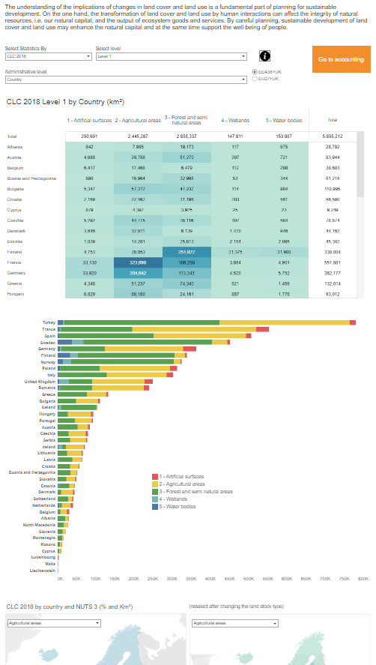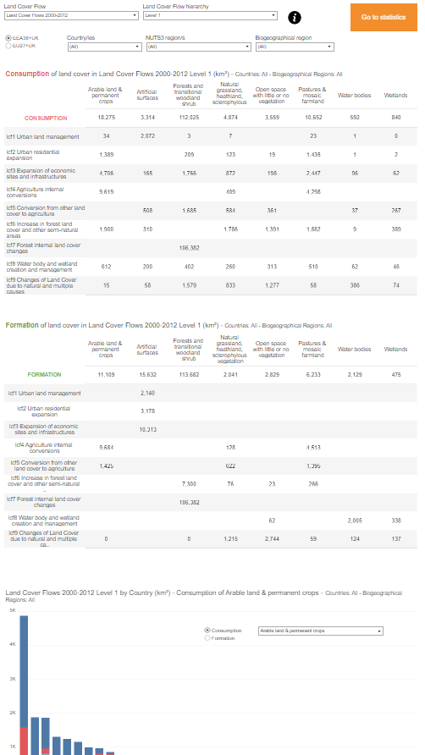
Figure 11. Example of how to organise dashboards. In this case, two different pages, with the content placed from top to down

Dashboard styling

Challenge

Styling is an essential aspect of dashboard design that can significantly impact how users perceive and interact with data. A well-designed dashboard should not only provide relevant information but also be visually appealing and easy to read. Styling elements such as font type and size, colour palette, and layout can greatly influence the overall user experience and ultimately determine the dashboard's effectiveness. In fact, research has shown that a visually appealing dashboard can increase user engagement and comprehension, leading to better decision-making and improved outcomes. Therefore, it is crucial to pay close attention to the styling elements of your dashboard to ensure it effectively communicates data insights and maximizes its impact on the intended audience.

Best practices

Fonts

Our usual practice has been to employ Tableau fonts, such as Tableau Book size 12 for filter titles and size 14 for Dashboard titles.
Initially, there was a proposal to align with the new EEA website's design by adopting the Roboto font (https://fonts.google.com/specimen/Roboto) for Tableau dashboards. However, subsequent testing revealed that this font was not rendering correctly in client browsers unless it was installed on their systems.
In light of this, and in accordance with EEA guidelines suggesting Arial as a web-safe alternative font, we recommend using Arial as the primary font in all dashboards. Arial shares a similar character and style with the Roboto typeface and is readily available as a system font, ensuring consistent display across different systems and browsers.

Colours

Incorporating appealing color palettes into dashboards is essential to enhance both aesthetics and functionality. Well-chosen color schemes not only catch the viewer's eye but also convey data effectively. By selecting harmonious colors and paying attention to accessibility, dashboards become more visually engaging and inclusive, ensuring that data insights are readily understood and retained by a broader audience.
Tableau software currently contains an EEA colour palette embedded, as shown in Figure 12. However, the new EEA website, launched in March 2023, has implemented a new colour palette, which is shown by Figure 13.

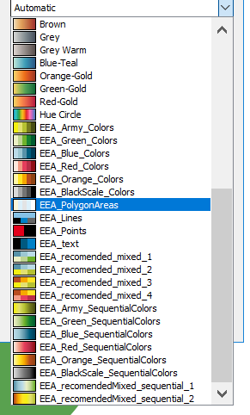
Figure 12. EEA colour palettes in Tableau
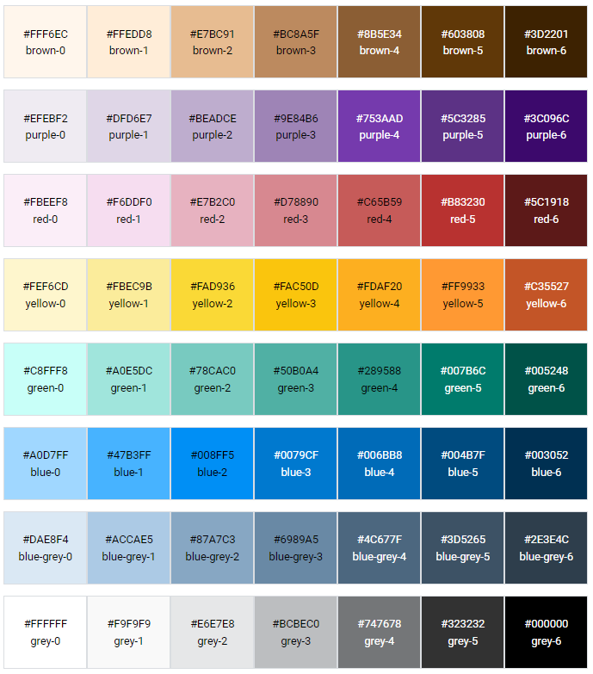

Figure 13. New EEA colour palette. Source: https://eea.github.io/volto-eea-design- system/docs/webdev/Guidelines/colours/

We strongly recommend using the new EEA color palette in all dashboards, and we hold hope for its eventual implementation within Tableau.

Maps

Maps in dashboards are of paramount importance, serving as a dynamic canvas to depict geospatial data, whether it involves plotting data points or delineating regions and countries as polygons. This multi-faceted approach allows for the visualization of data patterns and relationships, transforming raw information into meaningful insights. In a data-driven world, maps empower us to not only display information but also to comprehensively represent geographical aspects, making them an indispensable feature for both visual storytelling and informed decision-making.
When creating maps for dashboards, several key considerations come to the forefront.
First, determining the extent of the map, which defines the geographical area to be displayed, is crucial. Selecting the appropriate extent ensures that the relevant data and context are presented effectively. Define the map's extent to focus on the area of interest, minimizing empty space.
Map navigation features like zooming and panning are pretty important – they let users dive into the data and explore what they're curious about. But sometimes, you might not want users to mess with zooming in or out or shifting the map around. You can pick whether to let them do it or not, depending on what you want to say with your map.
The choice of background and foreground colours on the map also plays a pivotal role. It's essential to strike a balance that not only complements the dashboard's overall design but also ensures that the data points or regions are easily distinguishable and stand out for clear interpretation. Choose a muted, non-distracting background color for the map that complements your dashboard's overall color scheme, while the foreground colours should make use EEA colour palette.
Incorporating a clear and concise map legend is another essential best practice when designing maps for dashboards. A well-crafted legend helps users interpret the meaning of colors, symbols, or shapes used on the map. Ensure that it provides a key to understanding the data represented on the map, such as the range of values associated with different colors or the significance of various symbols. The legend should be positioned below or in free areas of the map, not obstructing the view of the data.
Additionally, tooltips, as discussed in next section, are also invaluable for providing additional context and information about specific map elements. Well-designed tooltips that appear when users hover over data points or regions can make the dashboard more informative and user-friendly, aiding in data comprehension and decision-making.
In some cases, legends or map-related filters can be places as floating objects within the map.
Some map examples included in existing Tableau dashboards are represented by Figure 14, Figure 15, Figure 16 and Figure 17.
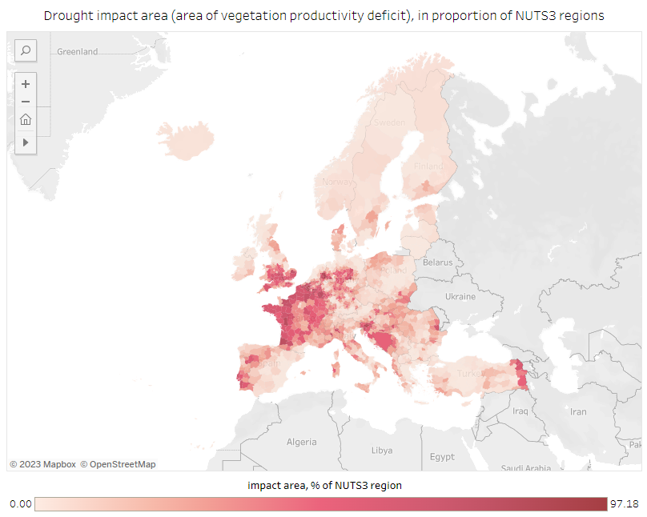
Figure 14. Map example, related to drought impact area.

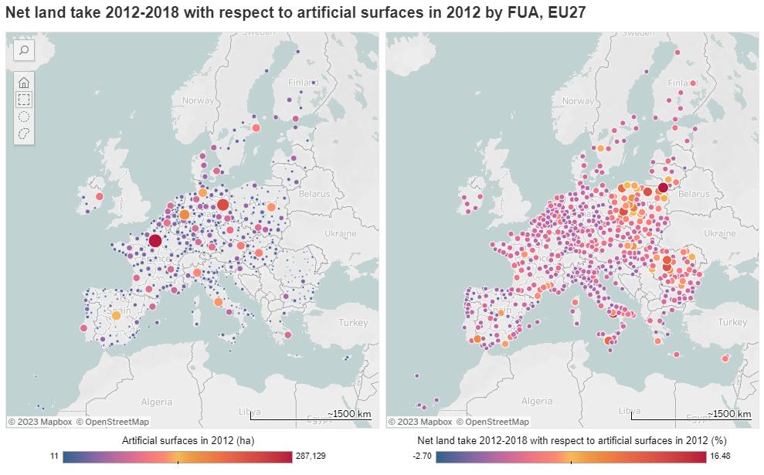
Figure 15. Map example, related to net land take vs. artificial surfaces.
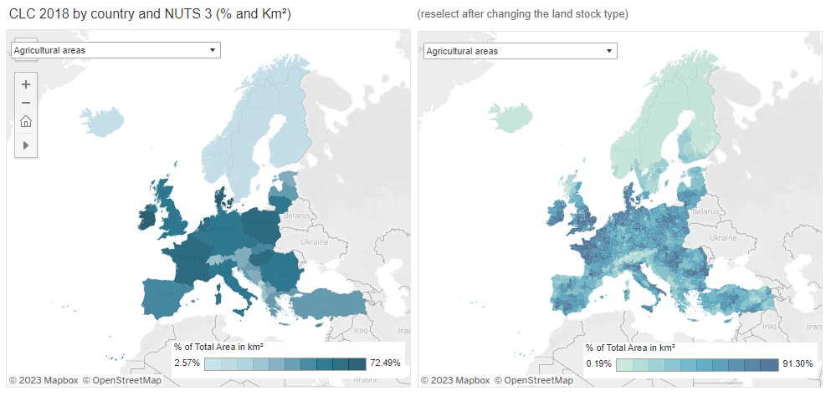
Figure 16. Map example, related to CLC statistics

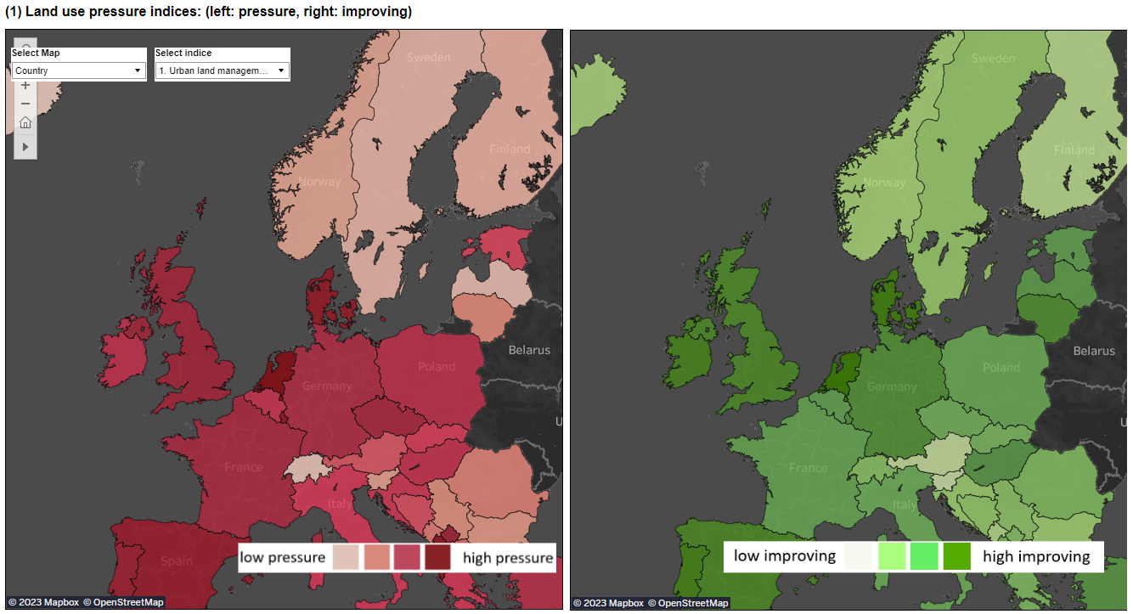
Figure 17. Map example, related to land use pressure indices.

Tooltips

Tooltips are like helpful sidekicks in dashboard figures, providing essential info when you hover over elements. They clarify complex data points, making charts and graphs easier to understand. Think of them as guides, offering explanations and insights that might be hard to spot otherwise. Tooltips not only enhance comprehension but also make the whole dashboard experience more user-friendly, helping users extract actionable insights from the data. In a nutshell, tooltips are key players in making data communication effective and insightful in dashboards.
It is advisable to make use of explanatory tooltips in different ways to make dashboards more understandable and user friendly. Tooltips can help users to better understand the numbers, as shown in Figure 18. Furthermore, tooltips can also include additional charts that provide a breakdown or a deeper look into the data the user is pointing to (see Figure 19).

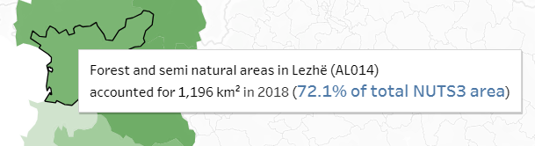
Figure 18. Example of tooltip information
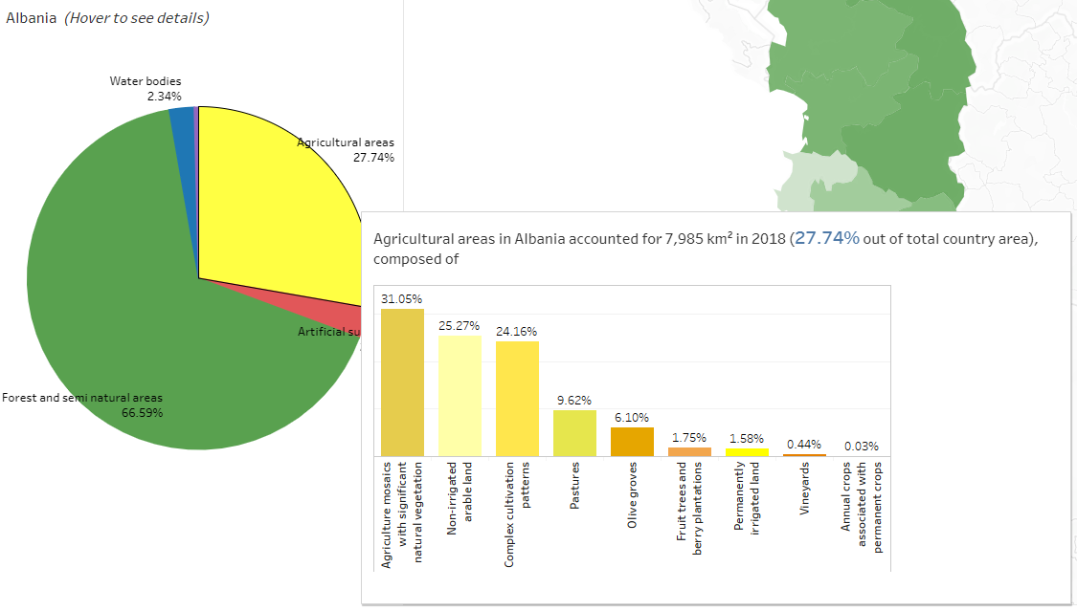
Figure 19. Example of tooltip information which contains a complementary chart

EEA visual identity

Considering that the ultimate objective of crafting dashboards is to share them through embedding on the EEA website or its thematic portals, we anticipate that adhering to the EEA's visual identity guidelines will be primarily addressed at the website or portal level. As a result, we have refrained from offering specific recommendations or guidance on this matter within the current set of guidelines.

Navigation and dashboard actions

Challenge

The challenge in organizing dashboard contents centered around the limitations of Tableau's traditional use of stories (see figure X). While these stories effectively compiled related dashboards, they lacked a structured narrative, making it difficult to guide users through a coherent and logical exploration of data. The absence of a clear storyline or sequential flow posed a challenge for conveying information in a way that facilitated meaningful comprehension. The traditional approach fell short in providing a deliberate and guided experience, leaving users to navigate through tabs independently, potentially leading to a less cohesive understanding of complex datasets. This challenge underscored the need for a more refined organizational strategy to enhance the effectiveness of data presentation in Tableau.
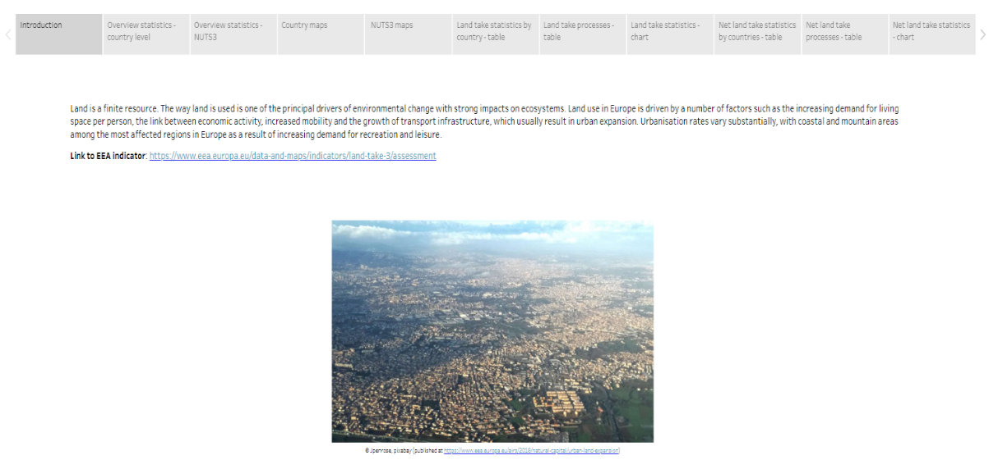
Figure 20. Tableau story organised by tabs

Best practices

In recent versions, Tableau introduced the navigation buttons, where you can use them to navigate betwwen different dashboards. Organizing dashboard contents into different simple pages interlinked by navigation buttons in Tableau introduces a dynamic and intuitive approach to data presentation. Unlike the traditional use of stories, which primarily served to compile related dashboards without a strict narrative, the introduction of navigation buttons allows for a more deliberate and structured exploration of data.
This feature enables creators to build a cohesive narrative by connecting pages seamlessly, guiding users through a logical flow of information. This approach proves particularly beneficial when dealing with multifaceted topics that require a step-by-step understanding. Users can navigate through the content intuitively, gaining insights progressively. The ability to build a page and incorporate navigation buttons enhances the user experience, making data exploration more engaging and facilitating a deeper comprehension of complex datasets.
Overall, this evolution in Tableau's functionality provides a valuable tool for storytellers, enabling them to weave a more compelling narrative and deliver information with greater clarity and impact.
Navigation buttons can be used in different ways. Figure x shows how they are used in the recommended layout, where navigation buttons at placed in the top-right corner and also at the bottom of the page.
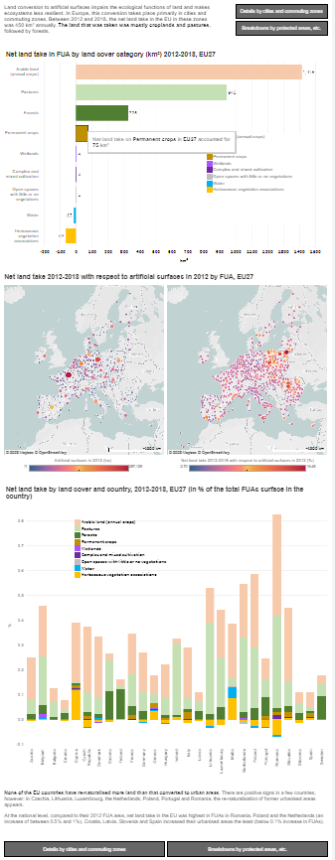
Figure 21. Usage of navigation buttons in a dashboard page layouted vertically
Navigation buttons can also be used to organise much more complex information (Figure 22) or to provide some metadata information (Figure 23).

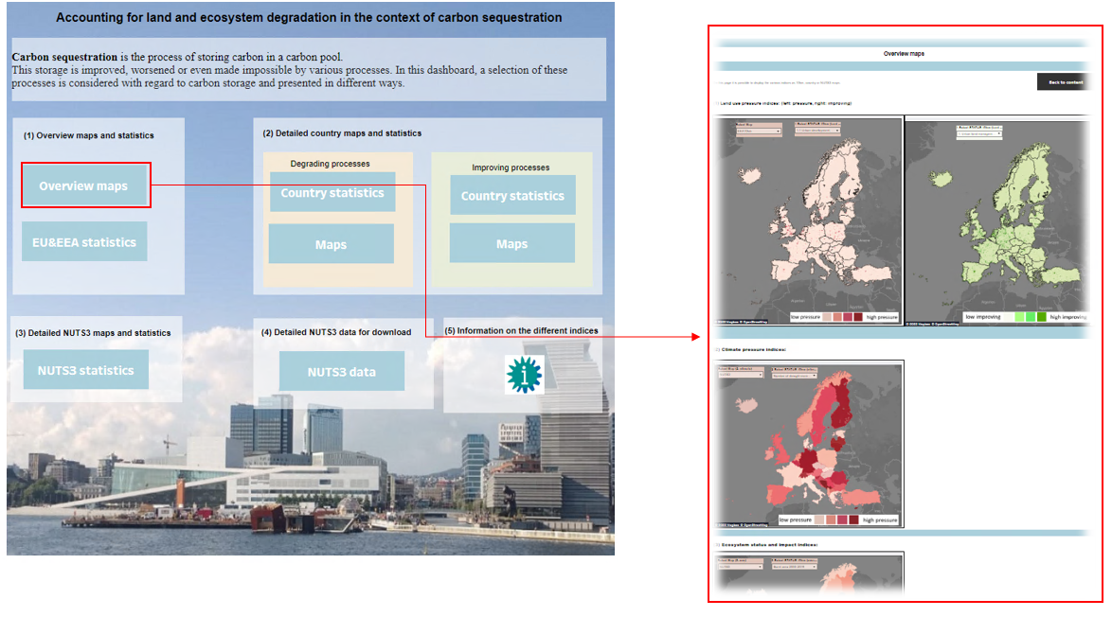
Figure 22. Use of navigation buttons to organise more complex information
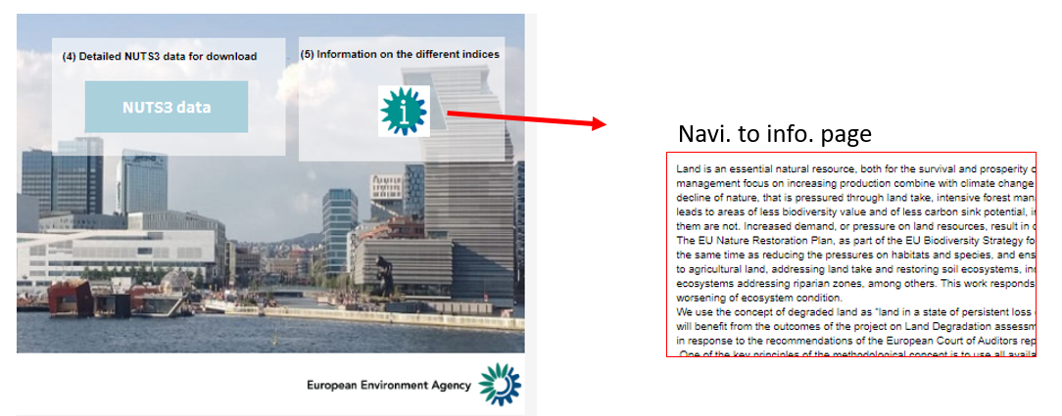
Figure 23. Example of navigation button to go to an information page

It is noteworthy that the existing guidelines provide recommendations for crafting simple dashboards, defined as single or few-pagers featuring textual content, charts, and/or maps or tables. However, these guidelines do not delve into the specifics of handling more intricate products comprising multiple dashboards with extensive statistics and information meant to be published collectively. In such instances, a separate discussion becomes essential with both the website team and the relevant thematic groups at the EEA. This discussion should focus on determining how to effectively publish such content, including considerations like the necessity of a landing page and other pertinent aspects.

Finally it is worth noting that one of the special characteristics of a dashboard is its interactivity. Different actions can be added to improve the user experience by interacting with the dashboard elements and getting some results, such as highlighting, filtering, etc.
It is recommended making use of the relevant dashboard actions when needed. The most relevant ones in Tableau are:
- Single View Filter Action
  - Allows using a single view as a filter for other views on a dashboard.
  - Example: If a dashboard contains a map, a bar chart, and a customer names table, selecting a region on the map filters data in other views to relate specifically to that region.
- Navigation Between Views, Dashboards, or Stories
  - Utilizes the Go to Sheet action to enable users to navigate quickly to related visualizations by clicking on a mark or a tooltip menu item.
- Interactive Web Page Display
  - Involves using a URL action with a web page object to interactively display web content within a dashboard.

Summary of proposed guidelines

These guidelines aim to improve communication, user engagement, and comprehension across diverse dashboards within the EEA, establishing a foundation for shared best practices. This is a short summary of the proposed guidelines from previous sections:
- Dashboard Types by Target Audience:
Challenge: Identifying and categorizing dashboards based on target audiences (B and C types).
Best Practices: Harmonize all dashboards intended for EEA's website or thematic platforms, adhering to guidelines and recommendations.
- Storytelling - Effective Communication:
Challenge: Designing dashboards for effective communication.
Best Practices:
  - Start with questions to define goals.
  - Know purpose and audience.
  - Fill in the preparatory template in Annex 1.
- Dashboard Sizes and Multidevice Approach:
Challenge: Choosing dashboard size (fixed, automatic, or ranged) and considering multidevice compatibility.
Best Practices:
  - For type B dashboards, aim for a fixed width (900-1100 pixels) and adaptable height.
  - For type C dashboards, use automatic layouts.
  - Adapt type B dashboards for mobile devices with streamlined layouts.
- Layout - Placing Dashboard Elements:
Challenge: Structuring dashboard elements effectively.
Best Practices:
  - Organize elements vertically for intuitive flow.
  - Prioritize content with top-down structure.
  - Optimize for mobile responsiveness.
  - Use tiled configuration; reserve floating elements for specific advantages.
- Dashboard Styling:
Challenge: Ensuring visually appealing and readable dashboards.
Best Practices:
  - Use Arial font for consistency across systems.
  - Incorporate the new EEA color palette for visual appeal.
  - Consider map, tooltip, and EEA visual identity guidelines.
- Navigation and Dashboard Actions:
Challenge: Organizing dashboard contents for coherent exploration.
Best Practices:
  - Use navigation buttons for a structured narrative.
  - Consider page-based layouts for multifaceted topics.
  - Employ relevant dashboard actions (filter, navigation, web page display) for interactivity.

Annex 1. Example filled-in template for dashboard development

(provided as separate Excel template)

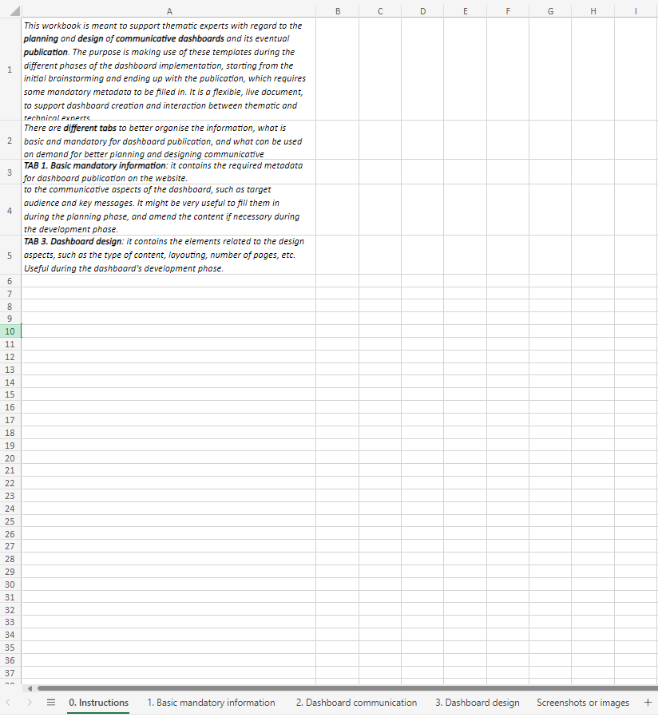
Figure 24. Instructions page in preparatory template

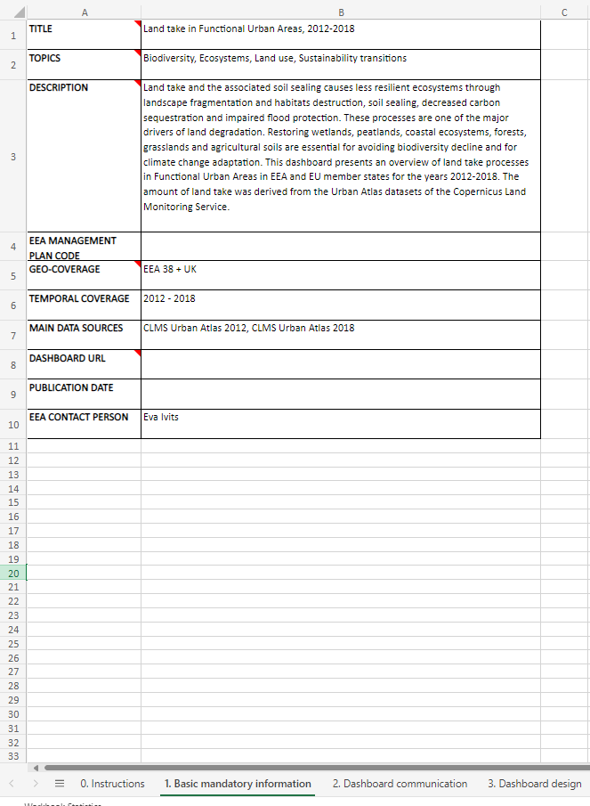
Figure 25. Basic mandatory information page in preparatory template

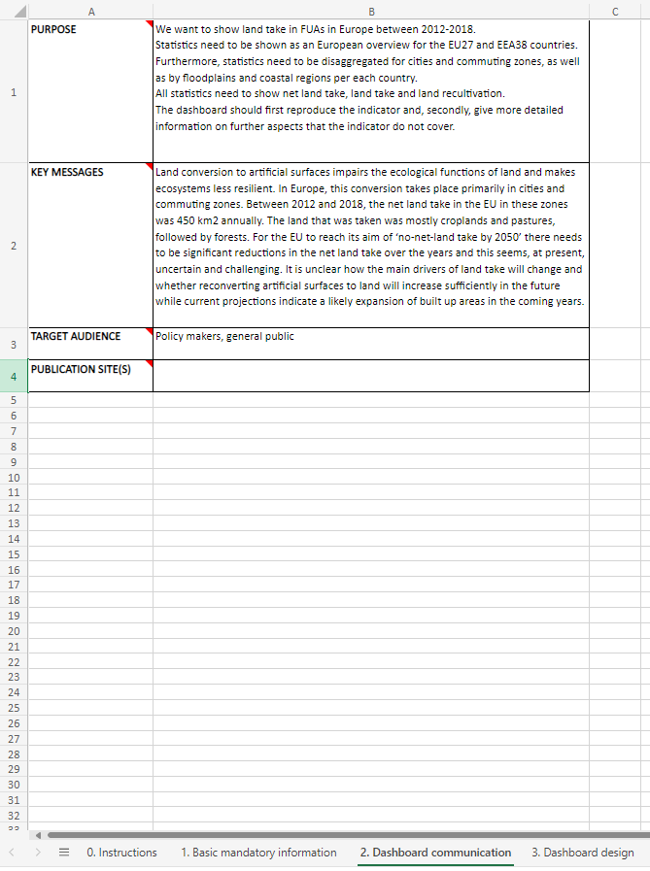
Figure 26. Dashboard communication page in preparatory template

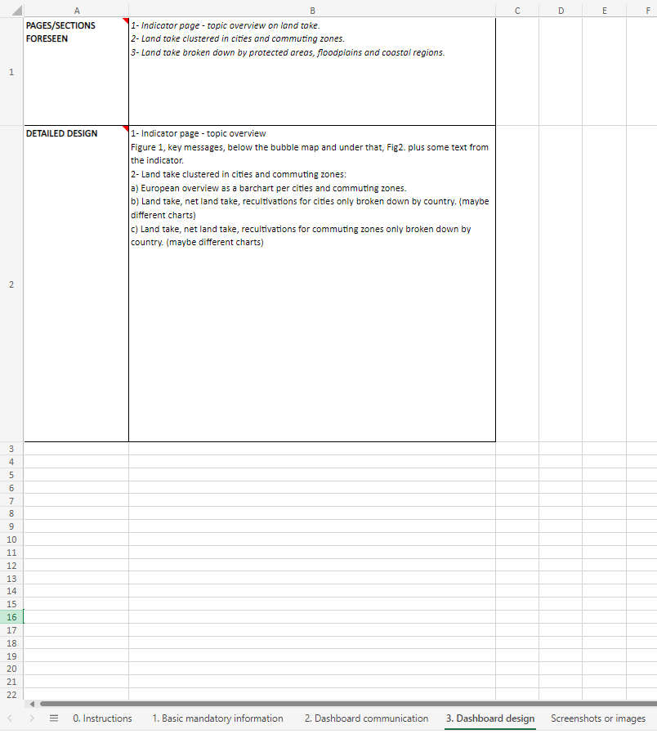
Figure 27. Dashboard design page in preparatory template

