[Title]

Title should include ‘in Europe’ at end if relevant.

**General**

* Keep paragraphs to five lines maximum when possible.
* **Bold** text should only be used to highlight a term – use sparingly.

**Summary**

This section contains the indicator at the aggregate level, i.e. EU, global or regional level.

The information contained here explains the indicator’s key focus. It is a summary including key messages, a graph and an assessment text.

**Summary** (Hard maximum of **500** characters without spaces)

The summary tells the reader about the indicator trend over the examined period and whether it helps achieve the associated policy objective, which can be either quantitative or directional. In the absence of a policy objective, it explains whether the trend is in the right or wrong direction in relation to the issue examined. If there has been an important change over the most recent period of the time series, e.g. over the last year, this is indicated too. Furthermore, if there is a quantitative target, it also indicates whether we are on track to meet it. If we are not on track, it explains the reasons preventing positive progress e.g. socio-economic drivers, implementation gap.

**Aggregate level**

**Figure 1.** Insert figure title, which should only refer to the phenomenon being measured.

Words such as ‘trend’, ‘status’, etc. should be avoided.

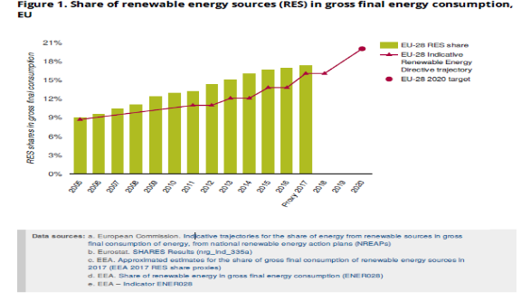

Please embed your figure here. The figure may be a chart, map or table.

* The figure should show data aggregated at the relevant level, i.e. global, EU or sectoral.
* If targets exist, it should also show these and, where possible, how the data are performing with respect to targets.
* If robust projections exist that are important to show, they should appear in the figure. In this case, the indicator definition in the supporting information section should clarify the assumptions behind the projections.
* Any external figure that is very important to the indicator (e.g. an indicator breakdown) can be made accessible via hyperlink.

**Notes:** Define any abbreviations here but avoid using them unless essential.

* Briefly explain anything the reader needs to know to understand the chart.
* Notes should only be used if absolutely necessary.

**Aggregate** level assessment (Hard max. **2,000** characters without spaces)

Keep the assessment text at the relevant aggregate level (i.e. global, EU, sectoral) and address the following:

* In one or two sentences, explain the environmental rationale of the indicator, i.e. why it matters for the environment that we see an increase/decrease in the value measured.
* In one or two sentences, explain the associated policy objective, which can be either quantitative or directional. Include more information on the policy objective and related references in the supporting information section. If there is no policy objective associated with the indicator, i.e. the indicator addresses an issue that is important for future policy formulation, explain instead why this issue is important.
* IF NECESSARY — Explain any mismatch between what the indicator tracks and what the policy objective/issue is.
* Qualify the historical trend (e.g. steady increase) and explain the key reasons (e.g. policies) behind it. If there is a quantitative target, explain if we are on track to meet it.
* IF NECESSARY — Explain any recent changes to the trend and why they happened.
* IF NECESSARY — Describe what needs to happen to see adequate progress in future, e.g. to remain on track to meet targets.

Please **cite your work** using the EEA citation style (i.e. EEA, 2020). Write a full reference list in the Supporting information section for easy upload to Zotero. If using a link, ensure the URL is correct and valid.

**Disaggregate level**

This section shows the indicator at a different level. For example, for an indicator with aggregated data at EU level, the information in this section will be at country level (i.e. for EU, EEA member and EEA cooperating countries). If more relevant, you can provide information at regional, local or sectoral level here.

**Figure 2**. Insert figure title, which should refer only to the phenomenon being measured. Words such as ‘trend’, ‘status’, etc. should be avoided.

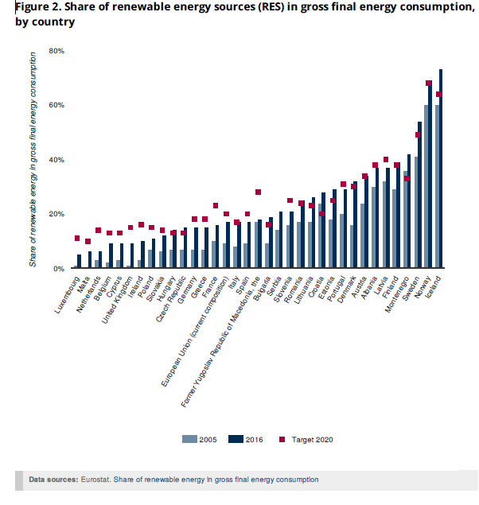

Figure 2 will provide additional information to support Figure 1. Ideally, it will show data by country (e.g. for the first and last years of the EU aggregate time series), including, for example, different country targets. If this is not relevant, regional or sector level information may be shown.

If appropriate, a query option could allow reordering (potential default ordering: best EU performer on top based on latest year’s data; best EEA member country; etc.) for the web version of the indicator.

If appropriate, the full time series of countries could be found via <https://www.eea.europa.eu/en/datahub>

Here users could reorder or hide some of the countries.

**Notes:** Define any abbreviations here but avoid using them unless essential.

* Briefly explain anything the reader needs to know to understand the chart.
* Notes should only be used if absolutely necessary.

**Disaggregate** level assessment (Hard max. **1,000** characters without spaces)

Depending on the indicator context, this text can provide information at country level or, if this is not relevant, at some other level, e.g. sectoral, regional level.

This text interprets the data represented in the chart rather than describing results, i.e. it provides explanations for some of the results.

The text related to progress at this level does not have to be comprehensive.

If there is no information that adds value to what is already visible there is no need to have any text.

**Supporting information**

**Definition** - clear definition of the indicator, including references to standards and classifications

FREE TEXT - max 600 characters with spaces

**Methodology** - summary description of the methodology applied to process the indicator (e.g. computational method, disaggregation, treatment of missing values, regional aggregates, quality assurance, etc.)

FREE TEXT - max 2,000 characters with spaces

**Policy/environmental relevance** - the degree to which the indicator meets current/potential needs of users

FREE TEXT – max 1,000 characters with spaces

**Accuracy and uncertainties** - includes, among others, comparability (geographical and over time)

FREE TEXT

**Data sources and providers** - link to the data sources (description, collection process, data providers)

AUTOMATIC - harvested from data

**Metadata**

**DPSIR** - Driving force – Pressure – State – Impact – Response + possible second choice

FIXED – drop down list with possible second choice

**EEA topics** - <https://www.eea.europa.eu/themes>

FIXED – Possible second and third choice

**Tags** – Indicator code, choose tags that are relevant to indicator for search optimisation

FREE TEXT

**Time coverage** - The length of time for which data are available

AUTOMATIC from data

**Geographic coverage** - The geographic area covered by the indicator

AUTOMATIC - harvested from data

**Typology** - Descriptive indicators (type A), Performance indicators (type B), Efficiency indicators (type C), Policy effectiveness indicators (type D), Total welfare indicators (type E)

FIXED – Possible second choice

**UN SDGs** - 17 goals from <https://w3.unece.org/SDG/Home>

FIXED – Possible second choice

**Unit of measure** - the unit in which the indicator is measured

AUTOMATIC from IMS v.3

**Frequency of dissemination** - the time interval at which the indicator is disseminated

FIXED from a list (from ‘every year’ to ‘every 6 years’)

**Contact** - [info@eea.europa.eu](mailto:info@eea.europa.eu)

AUTOMATIC

**References and footnotes**

**References** - citation of work in text deriving from another EEA product, organisation or person. List full bibliographic reference here. Please note that indicators will use Zotero referencing software. For information on referencing, please see Section 3 of the [EEA Writing manual](https://eea1.sharepoint.com/:b:/r/sites/Editing/Document%20Library/2.%20EEA%20writing%20manual%20(February%202020).pdf?csf=1&web=1&e=9E35W1).

AUTOMATIC via Zotero folder for indicators

**Information to be included in the next phase of IMS development (IMS v.4)**

**Institutional mandate** - legal acts/agreements assigning responsibility to EEA for producing the indicator

FIXED -> ROD - Other (any other legal act/agreement creating the reporting)

**Timeliness** - Length of time between data availability and the event of phenomenon they describe.

AUTOMATIC – from release year to reference year

**Related products** - Gallery of EEA products related to the indicator and older versions of indicators

How: AUTOMATIC