EEA, June 2024

Access to Climate-ADAPT case studies and ways to share case studies

According to its mandate, Climate-ADAPT supports stakeholders with multiple interests across all governance levels and sectors in the EU. Thus, it provides various tailored entry points to case studies to address the specific needs of each target audience.
It also invites users to share any potential case studies.

Access to case studies with map-based search options  Case study explorer  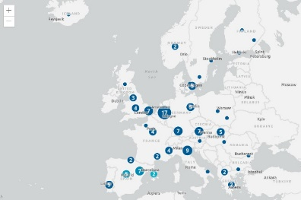 | Assessing and selecting adaptation options in the Adaptation Support Tool (AST) and in the Urban Adaptation Support Tool UAST  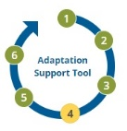  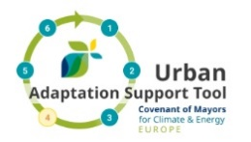 | Access to case studies for each policy sector  EU Sector pages  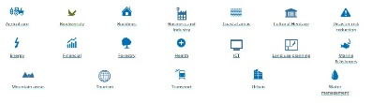
Access to case studies for adaptation in the health sector  European Climate and Health Observatory | Access to case studies for urban adaptation  Urban landing page | Access to case studies for adaptation in the forestry sector  Forestry landing page
Should you wish to share case studies, please click on the Share your information tab and follow the guidance or email Climate-ADAPT at: climate.adapt@eea.europa.eu

Please check those specific criteria to see if your proposed case study matches the scope and purpose of Climate-ADAPT case studies.

